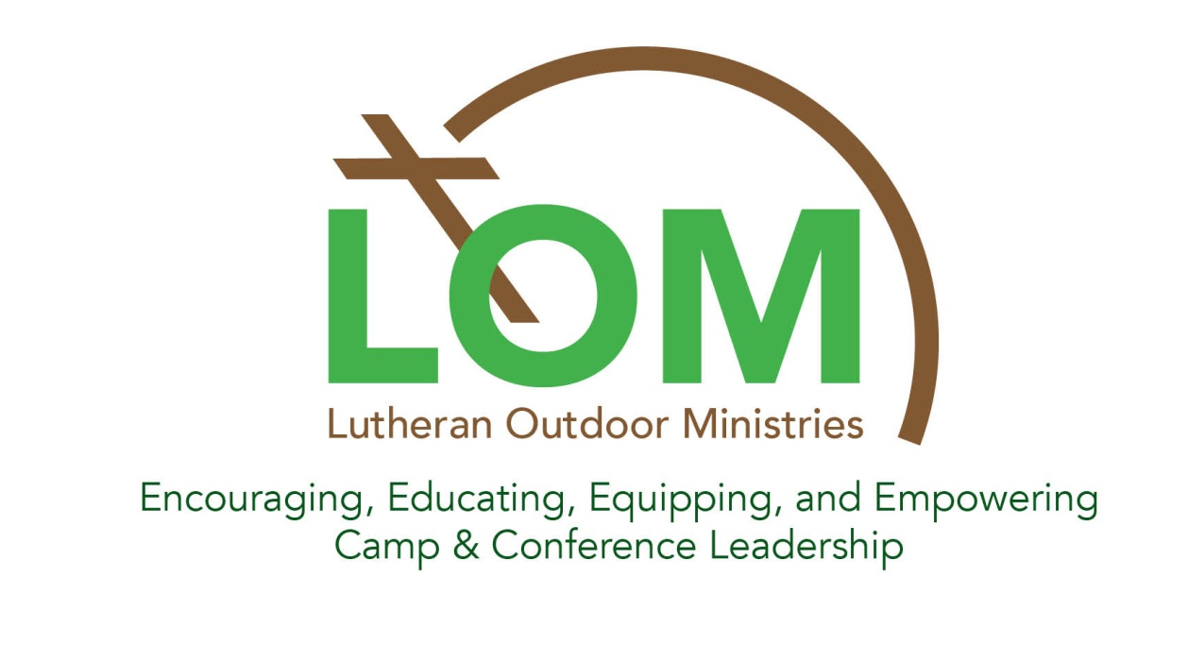
Executive Director Report to the Annual Conference
2016

It has been an honor and thoroughly gratifying to serve as the first executive director of Lutheran Outdoor Ministries (LOM). The ministries of the organizations that comprise LOM continue to repeatedly touch people in ways that inspire growing faith in Jesus Christ and proclamation of the Gospel throughout the world. The passion for ministry of those who provide professional and volunteer leadership in these organizations is evident in their dedicated service. Those who serve on the governing boards are ever mindful of their responsibility for the stewardship and mission of these treasured resources of the church. And everywhere I turn in this organization, I am finding a commitment to combine our skills, resources, and experiences in ways that make outdoor ministry, for the church and the world, a movement that transcends and multiplies our strength and vitality beyond what any of us can do on our own. For me and I know for everyone engaged in the life of LOM, this is gratifying work, indeed!
When I began serving as executive director of LOM I made the commitment to visit as many of our 133 sites as possible during the two-year term of my call. As of October 20, 2016, I have personally visited 65 of our sites. This has been a great way for me to “get a pulse” on the state of affairs throughout our network and to enhance the process for LOM keeping outdoor ministry leaders connected with each other. During the past decade, outdoor ministry organizations have been through some very challenging times. During the past year or so, however, there seems to be a generally emerging confidence in the future. For some, this is due to growing program participation; for others, it’s due to getting good feedback from all the hard and time consuming work of cultivating relationships with congregations, synods, and other institutions of the church; and for many it’s due to the good response from reaching out to persons and communities that don’t have traditional connections with the Lutheran church.
One thing all of our organizations have in common – in spite of the unique natural settings in which our ministries take place, these settings are all so extraordinarily beautiful! We outdoor ministry folks are very fortunate to work in the settings that we do.
Most of my site visits have been somewhat random and often driven by meetings and other LOM business in the general area of the sites I’ve been visiting. In some cases, however, I’ve been specifically invited to special occasions. Examples of this: representing LOM at the retirement observance for Randy Gullickson after 31 years of service as executive director at Lutherlyn (PA); speaking at the annual luncheon for donors at Flathead (MT); bringing an enthusiastic greeting from LOM to the annual Harvest Festival of Lutherwood (OR); being part of a Board retreat at Hungry Mother Lutheran Camp (VA) as they charted a future for their camp, full of hope and optimism; serving as a member of the synodical Mission Review Team for Sky Ranch (CO). What a privilege it is to be part of celebrations and deliberations like these, and great for LOM to have exposure in such happy settings.
I also relish the opportunities I’ve had to spend extended time in regional gatherings of LOM organizations. During the past year, this has included participation at the LOM gatherings of ELCA Region 5; ELCA Regions 7 & 8; ELCA Region 3; Texas LOM organizations.
Not all of my connections with LOM organizations have been dominated by joy and celebration. Times when there are changes in executive leadership can be particularly anxiety-producing for our camps and retreat centers. More and more, LOM is being recognized as the organization to which to turn in times like this. In many cases, these connections are being initiated by the organization in transition or experiencing some kind of crisis. In other times, I have been reaching out to organizations on behalf of LOM. Organizations currently experiencing or soon to experience transition in executive leadership are:
- Amnicon (WI)
- Camp Frederick (OH) – Dick Iverson will begin serving as interim executive director soon after Thanksgiving
- Luther Point (WI)
- Mount Cross (CA)
- Koinonia (NY)
- Lutherlyn (PA) – very close to an agreement with an interim executive director
- Wapo (WI) – Paul Hill retiring at the end of 2016
One of the most often mentioned wishes for LOM to provide assistance is for the securing of an interim executive director. Thanks to LOM Board member Meggan Manlove spearheading an effort on behalf of LOM and the ad hoc ecumenical organization known as Outdoor Ministry Connection (OMC), LOM will sponsor for the first time, in collaboration with the Interim Ministry Network, an interim executive director training event. It will be held May 8-12, 2017, at a place yet to be determined.
Another often mentioned request of LOM’s service is the gathering of information from around the LOM network. The initiative of the Technology and Communications Committee in doing a survey on compensation for outdoor ministry professionals has been received by many with great expressions of gratitude. It’s now time to support our member organizations with a similar survey on compensation for seasonal staff, and it’s of interest to many what proportions of operating budgets are going toward particular purposes.
All of us associated with LOM are well aware of the power and effectiveness of outdoor ministry experiences. Sometimes, those who are not as intimately and personally involved in these experiences are not as easily convinced. That’s why it’s so important for LOM to access every available resource for documenting the value of the experiences we provide. We are grateful for the research of The Effective Camp Research Project spearheaded by Jake Sorenson, and we will continue to support and encourage him for this gift he is so freely sharing with LOM.
I have had the rare privilege to be the first executive director of this great organization. And I have also had the benefit of not having to begin my work from “ground zero”. On the contrary, one thing that continues to impress me is the depth of development of this young organization. LOM has had impressive development in just a few short years, all the more impressive because it has been accomplished with just a few very part-time contract staff and a huge amount of volunteer effort. The signature resources of LOM – the Annual Conference, the Leadership Training Event (LTE), the Board Training Event (BTE), and the annual production of summer camp curriculum – all offer testimony to the passion and commitment of those for whom our work together is so important. The Board and I have been of the consensus that the work of an executive director should add value of our organization, not replace value. We continue to feel strongly that a strong attribute of LOM is the predominance of volunteer service. Thank you volunteers, one and all.
And our contract staff! I’d be lost without them and all of LOM would be in a much less favorable position without the benefit of their expertise. Thank you, from the bottom of my heart, to:
- Jon Skogen, administrator
- Randy Youngquist-Thurow, events coordinator
- Chad Hershberger, webmaster
- Aurice Worley, bookkeeper
- Andrea Lee, curriculum production manager
One of the values that LOM has added with the services of a full-time executive director is significant growth in our capacity for outdoor ministry advocacy and collaboration. Some examples –
- Growing collaboration with the ELCA Youth Ministry Network. LOM’s participation in the YM Extravaganza last February had an enthusiastic reception.
- Deepening exploration of partnership with the ELCA Youth Gathering. This is being manifested in several ways, not the least of which is LOM participation in the Theme-Setting Team for the 2018 Gathering; LOM and the Gathering will share the same theme for the 2018 event and the LOM curriculum.
- Acknowledgement of LOM as a full partner in the ELCA First Third of Life Faith Formation Network as evidenced by the executive director’s participation in the Faith Formation Summit last April. Some of this came as a result of the Region 7&8 Faith Formation Summit in October, 2015, in which many LOM organizations participated.
- LOM is having a growing presence and influence in the organization known as Lutherans Restoring Creation.
- LOM was a featured ministry in the last gathering of the ELCA Mission Interpreters, August 26-28, 2016, at Joy Ranch (SD).
- LOM and the Lutheran Campus Ministry (LCM) Network now have a ”conference swap” agreement. Gary Schaeffer, formerly of Koinonia (NY,) represented LOM at the LCM conference last June; Deb Abbott is representing LCM at our Conference in November.
- The collaboration with Lutheran campus minister Reggie Price in organizing an LOM summer camp recruiting night at Morgan State University in Baltimore, a historically Black university.
- Kelsey Ellis, formerly of Carol Joy Holling (NE), Phil Bramley of Bethel Horizons (WI), and Justin Landry, formerly of Camp Frederick (OH), represented LOM at the Covenant Mission Cluster Gathering last March.
- Plans continue to materialize with Lutheran Volunteer Corps (LVC), the ELCA seminaries, and LOM, for structured vocational discernment retreats for summer camp staffs.
- There is strong interest being expressed in exploratory conversations with Lutheran World Relief (LWR) and Lutheran Immigration and Refugee Service (LIRS) for deeper collaboration with LOM and our member organizations.
- Openness has been expressed by leaders of Lutheran Men in Mission and Women of the ELCA for exploring how deeper collaboration opportunities.
- The support of this Conference by major sponsors: Gronlund, Sayther, Brunkow (GSB), Portico, Thrivent, and Mission Investment Fund (MIF), as well as all the exhibitors from among our Business Members and Ministry Partners.
- The invitation extended by Lutheran Services in America (LSA) for inclusion of LOM member Jeff Bluhm in the planning team for their annual CEO Academy.
- Nathan Pile and Randy Youngquist-Thurow represented LOM at the meeting of the ecumenical camp and conference group known as Outdoor Ministry Connection (OMC). This organization includes our LOM counterparts in many of the mainline Protestant denominations.
- Andrea Scofield of the LOM Education Committee represented LOM in the interdenominational group that plans the Compass Points continuing education events for outdoor ministry professionals and spearheaded by the Presbyterian Camp and Conference Center Association (PCCCA).
- The agreement with the “Two Bald Pastors” podcast platform for LOM use of the same platform for LOM podcasts 6–8 times per year.
- The agreement with American Camp Association (ACA) for a 15% discount in the annual fees to ACA for all LOM camps accredited by ACA. This agreement will go into effect on May 1, 2017.
- The agreement with Donor Search, an organization offering vast donor research resources to non-profit organizations. Starting on January 1, 2017, LOM organizations will have access to their resources for an annual fee of $650. This fee is ordinarily $3,000.
We are grateful to Rev. Gordon Straw of ELCA Churchwide staff. He had a pivotal role in securing an ELCA grant of $3,000 to cover expenses for non-rostered staff of LOM organizations to be part of meetings and gatherings like many of those listed above.
It’s obvious that the services of an executive director have facilitated an expansion of the scope of activity and influence of LOM. In order to be financially sustainable, it will be necessary for LOM to expand its base of financial support. With the guidance of the LOM Development Committee and the support of the LOM Board, a major focus of my work has been to encourage organizations and individuals to “ramp up” financial contributions to LOM. We have made progress in the first ten months of 2016. If you and/or your organization have not yet made a contribution to LOM for 2016, please do so before the end of the year. And please include an increased financial commitment to LOM in your budget for 2017. Our capacity to continue growing momentum for the formation of faith, for the formation of bold and faithful leaders, and for a church full of vitality, depends on it.
Here’s a summary of where financial development work stands as of October 20, 2016:
Statistics of Organizational Giving–
Level 2015 1/1/16-10/20/16
$25-$499 2 3
$500-$999 33 8
$1000-$1999 8 9
$2000-$3499 5 4
$3500-$4999 0 1
$5000+ 0 2
TOTAL 48 27
AMOUNT $43,165 $57,331

Statistics of Individual Giving–
Level 2015 1/1/16-10/20/16
$25-$99 20 13
$100-$299 27 23
$300-$499 3 9
$500-$999 7 9
$1,000 + 0 6
TOTAL 57 60
AMOUNT $11,363 $29,981

Auction for 2015 –
Goal: $15,000
Actual: $26,177.61

I believe that LOM is poised to provide leadership for our whole church to be vibrant and relevant and fully connected to individuals and communities in ways that will bear witness to God’s grace and love throughout the whole world. I am excited about the ways that his hope and optimism is reflected in the strategic plan that will soon be brought forward by the LOM Board. And I want you to know that it is my distinct pleasure to serve on your behalf in the ways that I do.
Respectfully submitted,

Don Johnson, Executive Director
Lutheran Outdoor Ministries

